SEA DONKEY'S FINAL OCEANS SEVEN SWIM!

SPONSORSHIP FORM

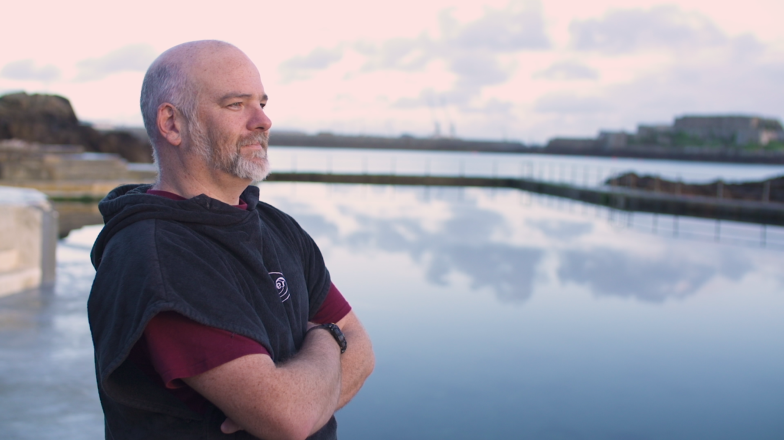

Ady Sarchet a.k.a. the "Sea Donkey" is scheduled to swim the Cook Strait – the 16 miles from the North Island to the South Island in New Zealand – weather permitting between 1 and 6 March 2020.

The Cook Strait is renowned for its chilly waters, its strong (and sometimes unpredictable) currents, its jellyfish and its relatively common shark sightings.

If successful, Ady will join the 20 elite swimmers who, as at the beginning of February 2020, have conquered the Oceans Seven.

Ady is swimming to raise money for Guernsey Disability Swimming LBG ("GDS") (Guernsey Charity Number CH496) in support of the Beau Sejour Leisure Centre's "Poolpod Appeal".

The Poolpod Appeal

Beau Sejour's existing pool hoist (which is used to lift swimmers with mobility difficulties into and out of the pool) is coming to the end of its lifespan.

Rather than simply replace the existing pool hoist with an identical replacement, Beau Sejour would like to take advantage of a revolutionary technological advance – Poolpod https://poolpodproducts.com

Poolpod is a multi-award winning swimming pool lift which was developed for the London 2012 Paralympic Games and which is now transforming pool access.

Poolpod is an attractive option for swimmers with a wide range of mobility difficulties from disabled swimmers, swimmers with injuries and parents carrying babies and young children.

Poolpod can lower the demands on lifeguards' time by offering a greater level of independence to swimmers.

A new Poolpod, supplied and fitted at Beau Sejour, together with two specialist wheelchairs enabling those with profound disabilities to access the pool for the first time and thus ensuring "Access for All", will cost £28,000.

For a short video explaining the benefits of Poolpod over the existing pool hoist go to https://vimeo.com/53098271

Sea Donkey said …

"I used to watch snooker with my Dad on an old black and white television. It was great … until we watched snooker on a colour television for the first time. The old pool hoist is like that old black and white television. It did its job admirably, but its design is closer to a medieval ducking chair than a modern piece of sporting technology. The old hoist is not the most dignified method of entering the water for swimmers and robs swimmers of their independence as it has to be operated by a third party (usually a lifeguard or similar). Poolpod is a game-changer. Poolpod provides swimmers with a dignified method of entering the water and actively promotes the swimmer's independence by not requiring a third party to operate it. Poolpod is the ultimate empowerment of swimmers with mobility issues and getting one for Beau Sejour is a cause I could not ignore".

Legal Notice

In the event that the Poolpod is not acquired, for any reason whatsoever, all funds raised will be applied towards the general charitable purposes of GDS.

Donate

If you would like to help the Sea Donkey get a Poolpod for Beau Sejour go to https://giving.gg/donate/Event/0/Donate-to-Guernsey-Charitable-Event and click on “Sea Donkey Poolpod Appeal – Guernsey Disability Swimming LBG”.

Alternatively, please use the Sponsorship Form attached.

More on Sea Donkey

If you would like to learn more about Sea Donkey go to seadonkeyfilm.com

SEA DONKEY'S FINAL OCEANS SEVEN SWIM!

SPONSORSHIP FORM

Name of Team | Name of Team Leader

Email Address of Team Leader (if any) | Telephone Number of Team Leader

Name of Donor | Address of Donor | Amount of Donation | Paid Y/N

All cheques should be made payable to “Guernsey Disability Swimming LBG”.

Team Leaders should hand completed forms and donations to the Reception Desk at Beau Sejour Leisure Centre, Amherst, St Peter Port, Guernsey GY1 2DL.

Queries to adriansarchet@cwgsy.net

